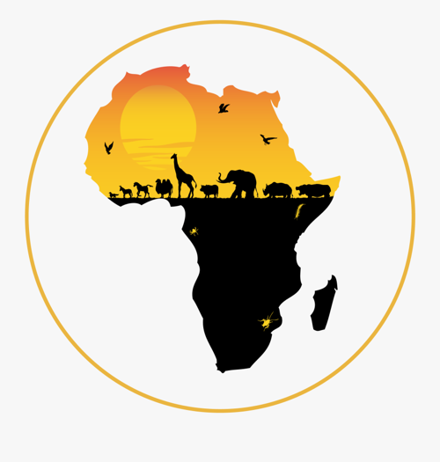
Dear Parents and Carers,
Welcome back to summer term in Year 5. The sun is shining, and we are ready to take our learning outdoors. On that note, please ensure your child has their water bottle and hat in school every day. Sun cream should be applied before school (a small top-up can be placed in their bag).
Our topic is ‘Africa’ this term, and through this we will explore a whole range of topic-based learning linked to areas across the curriculum.
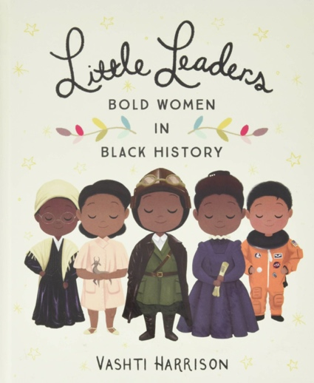
English
Our class texts are ‘The Butterfly Lion’ and ‘Simba and Saba’. This will also be supplemented with books around the Little Leaders series focusing on significant Black figures. Through these texts and links to our topic, we will study biographies, story writing around different cultures, poetry and persuasion linked to Fairtrade. Every child will continue to be heard reading, either individually or as part of whole class guided reading session.
Maths
In Maths this term, we will revisit and continue with the unit on Fractions. We will also be covering our second unit of Decimals and hoping to cover most aspects of the Geometry and Measures units. We will be aided in using the Power Maths resources to cover these units, alongside parts of White Rose Maths and Fluent in Five to keep up with daily Arithmetic Practise. Additionally, we encourage the children to use TT Rockstars and Doodle Maths as much as possible to keep skills sharp and fresh.
Science
Science this term will include: Properties of Materials – involving lots of practical activities and investigations, and Life Cycles in Plants and Animals, including puberty in humans.
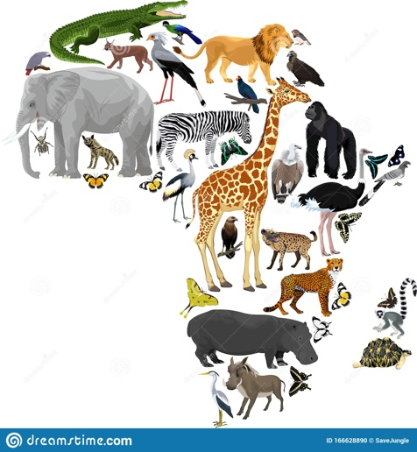
Topic
Our topic work this term will be based on ‘Africa as a continent’. We will look at, and compare different countries within Africa. This will include each countries physical and human characteristics, exploring their culture, food, transport and lots more. We hope to make significant links with our link school in Ghana and learn, first hand, what is it like to live in Africa.
Art and D.T.
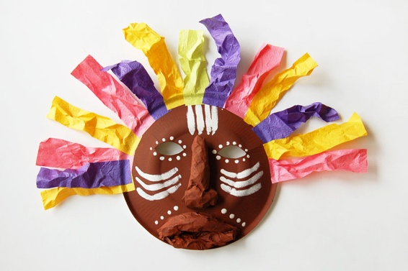
As part of our work on Africa, we will be designing and creating African clay pots– focusing on key clay skills. We will also be experimenting with some of the skills and techniques African girls are taught, which includes weaving and sewing. We will also be creating African masks and learning about their tribal importance.
R.E.
In R.E. this term we will explore Islam and Muslim beliefs about Allah. Children will have the chance to understand the importance of Ramadan and make links to our Ghanaian link school.
Please feel free contact us if you have any questions or concerns regarding home learning through Class Dojo and we will reply as promptly as possible (Mon-Wed Mrs Pinsent and Thurs-Fri Miss Major).
Reminders:
1 - PE Kits everyday (if sent home in it kit, it needs to come back the next school day)
2 - Water bottles in school everyday
3 - Hat for the sunny days and sun cream
4 - Swimming kits on Fridays (first half term only)
Enrichment Activities this term:
- PE with Mr Cave
- Art with Ms Chapelle
- Eco Ed with Audrey
- Gardening with Mrs Bradfield

Homework
Homework will be set via Google Classroom every Friday. Please ensure your child completes it as it really does benefit their learning.

Yours sincerely,
Mrs Pinsent and Miss Major

